Strategy and Guideline for Implementation of IHR (2005) for Management of PHEIC at Points of Entry (PoE)

Institute of Epidemiology, Disease Control Research (IEDCR)
Ministry of Health and Family Welfare
Technical Support: World Health Organization
Abbreviations:
ACI: Airports Council International
AHO: Airport Health Officer
ATYA:
CIF: Clinical Information/Investigation Form
CS: Civil Surgeon
DRRT: District Rapid Response Team
FAO: Food and Agriculture Organization
IAEA: International Atomic Energy Agency
IATA: International Air Transport Association
ICAO: International Civil Aviation Organization
ICDDR,B: International Centre for Diarrheal Disease and Research
ICRC: International Committee of the Red Cross
IEDCR: Institute of Disease Control and Research
IHR : International Health Regulations
IFRC: International Federation of Red Cross
IMO: International Maritime Organization
IMT: International Maritime Treaty
IPH: Institute of Public Health
ISF: International Shipping Federation
MoH&FW: Ministry of Health and Family Welfare
MT(Lab)Medical Technologist(Laboratory)
NIDCH: National Institute for Diseases of Chest and Hospital
NRRT: National Rapid Response Team
OIE: Office International des Epizooties
PHEIC: Public Health Emergency of International Concern
PHO: Port Health Officer
PoE; Port of Entry
PPE: Personal Protective Equipment
RCS: Red Crescent Societies
RRT: Rapid Response Team
SOP: Standard Operating Procedure
UH&FPO: Upazilla Health & Family Planning Officer
UIR: Union of International Railways
UNDP: United Nations Development Programme
UNICEF: United Nations International Children’s Fund
UNWTO: United Nations World Tourism Organizations
URRT: Upazilla Rapid Response Team
WHO: World Health Organization
Strategy and Guideline for Implementation of IHR (2005) for Management of PHEIC at Points of Entry (PoE)

- Background and Introduction
Global achievement of international public health security has become one of the major challenges especially in the context of emerging and re-emerging diseases. Today’s highly mobile, interdependent and interconnected world provides myriad opportunities for the rapid spread of diseases. Designated exit and entry points, e.g. airports, maritime ports and ground crossings which are accessible to peoples, animals and cargoes provide mechanisms and opportunities for spread of infectious diseases, including SARS and influenza etc.
The International Health Regulations are a global legal framework for preventing and responding to the international spread of diseases while avoiding unnecessary interference with international traffic and trade. The revised International Health Regulations, referred to as IHR (2005), were adopted by the World Health Assembly in May 2005 and entered into force in June 2007 in Bangladesh.
Implementation of IHR (2005) at Point of Entry is an important step for preventing spread of highly communicable diseases across borders. Recent assessment of core capacity for implementation of IHR (2005) in Bangladesh revealed the existing gaps at the health facilities and the PoEs for implementation of IHR(2005). It needs strengthening and or building up of core capacities at the health facilities and at some PoEs implementation of IHR. The strategy and guideline for implementation of IHR (2005) for Management of Public Health Emergency of International Concern is intended to be used for application of IHR (2005) at PoEs.
Under IHR (2005), the following diseases have been identified as Public Health Emergency of International Concern (PHEIC) (Annex 2). Among them, 4 diseases [Small pox, Poliomyelitis – wild type, influenza with novel virus, Severe Acute Respiratory Syndrome (SARS)] are always notifiable irrespective of number of cases i.e even a single case has to be reported. For other diseases, 2 of the four pre- set criteria as indicated by IHR (2005), need to be fulfilled for notification as per the decision instrument. Measures must have to be taken for detection and management of PHEIC at PoE.

- Strategy and Guideline for Implementation of IHR (2005) for Management of PHEIC at Points of Entry (PoE) in Bangladesh

The IHR (2005) describes two general types of core capacities that must be in place at designated airports, maritime ports and ground crossings.
- The capacities for all times
- Medical service:
  - Provide access to appropriate medical services including diagnostic facilities having adequate staff, equipment and premises located so as to allow the prompt assessment and care of ill travelers;
  - Provide transport facilities with necessary equipment and trained personnel for ill travellers to an appropriate medical facility.

- Safe environment: to ensure a safe environment for travellers following utilities must be present at the PoEs:
  - potable water supplies;
  - eating establishments;
  - flight catering facilities; foe airports only
  - public washrooms;
  - appropriate solid and liquid waste disposal services
  - trained personnel for the inspection of conveyances and other potential risk areas;
- Vector control: to provide a need based programme with trained personnel for the control of vectors and reservoirs in and around the points of entry;
- Maritime Declaration of Health by Masters of Ship to port authority: Review and adoption and practice of the declaration; (Annex 10)
- National Aircraft /Port Health Act and Rules for designated PoE: Review and update of the rules and acts;
- Contingency plans for implementation of IHR at points of entry during emergency health situation: Development and adoption of the contingency plan;
- Guidelines for Ship Sanitation: Development and revision of the guide line; (Annex 9 )
- Plant quarantine system: Development and strengthening of plant quarantine system.
- The capacities for responding to events that constitute PHEIC
- Provision for appropriate public health emergency response
  - development and implementation of public health emergency contingency plan;
  - nomination of a coordinator and contact point at PoE;
  - involvement of public health and other relevant agencies and services.
- Provision for submission of Health part of Aircraft General Declaration by the Captain/crew member to the airport authority in case aircraft coming from an infected area; (Annex 11 )
- Provision for assessment of and care for affected travellers or animals by establishing arrangements with local medical and veterinary facilities for their isolation, treatment and other support services;
- Provision of appropriate space, separate from other travellers, to interview suspect or affected persons;
- Provision for the assessment and, if required, quarantine of suspect travellers, preferably in facilities away from the point of entry;
- Application of recommended measures to disinfect, decontaminate, derat or otherwise treat baggage, cargo, containers, conveyances, goods or postal parcels including, when appropriate, at locations specially designated and equipped for this purpose;
- Application of entry or exit control tools for arriving and departing travellers; and
- Provision of access to specially designated equipment, and to trained personnel with appropriate personal protection, for the transfer of travellers who may carry infection or contamination;
- Establishment of animal quarantine system;
- Provision of personnel for vector surveillance and control activities;
- Review and adoption of Ship Sanitation Control Certificate (for sea port only) according to IHR (2005).
Reference: IHR (2005) 2nd Edition: Annex 1 Part B Page 41-42
- Development of Physical Facilities
At a very few PoEs (like ZIA and Chittagong Airport and Seaport) of the country there are physical facilities for health service. These health facilities need expansion. At other PoEs, where there are crossing of travellers, animals or cargo physical facilities have to be established.
- Health Support desk:
During cross border spread of a PHEIC, Health Support Desk should be set up at different PoEs which will operate 24/7 with adequate manpower and logistic).
- Quarantine & Isolation facility
Guideline and SOP for isolation and quarantine have to be developed according to the need. The designated hospitals should have Isolation units for the respective PoEs. Presently, at the central level an Influenza Ward has been established with isolation facilities at NIDCH, Mohakhali, Dhaka. There is plan for establishing isolation units in all the districts of the country by 2009. Already, isolation units have been established in 29 districts. Quarantine measures will have to be undertaken as per particular situation of the PHEIC. Suspected cases can be quarantined in the house, designated hospital or other settings nearby the PoE.
- Manpower Development and training for strengthening health services at PoE
Except a few, most of the PoEs of the country have no permanent manpower to provide health support for the travellers. The health personnel of the nearby government health facility (Upazila Health Complex or District hospital) are assigned to work at that specific PoE in addition to their own responsibility when required. To provide better health support to the travellers, the following measures have to be undertaken
  - Strengthening (where needed) of ‘Public Health Units’/port health office with required manpower which should include Physician, Nurse, Ward boy / Aya, Sweeper, Pharmacist, Medical technologist
  - Provision of orientation and refreshers’ training for designated personnel at PoE for IHR.
  - Provision of orientation and refreshers training of designated nearby hospital staffs, e.g. physicians, nurses, ward boys, drivers, sweepers and other auxiliary staff,
  - Provision of supervision and monitoring for implementation of IHR at PoE.
- Logistics
Adequate logistical support has to be ensured at PoE health unit to provide emergency medical care for ill travellers and management of travellers with PHEIC. The logistics include different kinds of forms, medicines, infection control materials, vaccines, sample collection kits, ambulance and communication aids.

- For Port Health office: CIF (Annex 4), Health cards (Annex 5) Thermometer, Blood pressure instrument, Stethoscope, Disposable Tongue depressor, Ice pack, scissors, PPE, mask, gloves, disinfectants, soaps, tissue paper, waste paper bin, Sample collection kit (Tongue depressor, polyester fibre tipped applicator, collection vial containing Vial Transport Media (VTM), disposable syringe, needle, test tube/cryovials, test tube rack tourniquet, cotton, band aid, marker pen, ice pack in vaccine box).
- For Health Support Desk: Health cards, thermometer, flow chart (Annex 7)), mask, gloves, disinfectants, soaps, tissue paper, waste paper bin, hand mike, flyers (Annex 7), posters (Annex 7), banner (Annex 7), table, chair
- For Patient carrying: Ambulance
- Emergency stockpile: Antibiotics, Antivirals, Antipyretics, Vaccine, disinfectants, PPE.

- Diagnostic Facilities
There have to be diagnostic facilities with designated laboratories at the health facilities or nearby the health facilities for rapid detection of PHEIC preferably at nearby health facility. If necessary, the nearby private laboratories can also be earmarked for specific tests.
    - Manpower: Provision of Laboratory Medicine Specialists, Medical Technologists, Lab Attendant, Sweeper in the designated laboratories.
    - Sample collection: Measures have to be taken for collection of specimen at PoE for PHEIC. Medical technologist and Lab attendant may be posted at designated PoEs collection of samples from suspected travellers. If not possible for whole time, they may be deputed during emergency situations. On the other hand, health staff working at the PoEs may be trained for that purpose to tackle emergency situation.
    - Sample Storage and Transport: Samples have to be stored as specified for the specific disease and needto be transported according to the instruction from the lab where it will be tested.
    - Sample Testing: The samples will be tested at the designated laboratory for the specific disease. Preliminary tests might be done at local designated labs and confirmatory tests will be done in WHO reference laboratory situated within the country or abroad. Presently Institute of Epidemiology, Disease Control and Research (IEDCR) do the confirmatory test for Influenza and National Institute of Public Health do test for Polio.
    - Reporting: The test result should be available within the shortest possible and agreed upon time.
    - Infection Control: All infection control measures have to be undertaken during sample collection, sample storage and transportation and testing of the sample. Adequate number of PPEs, masks and gloves should be in stockpiled for the purpose.

- Screening of passengers
Screening will be instituted at PoE through establishment of Health Support Desk. Before starting screening, health and other concerned personnel will have to be oriented on the evolving health issue, personal protection and flow chart of management of cases. The flow chart might be as follows:

      - Reporting of travellers to the Health Support Desk before immigration
  - Those having sign /symptoms of ongoing PHEIC
  - Arriving from PHEIC affected countries or
  - Those who have travelled to those affected countries during incubation period of the particular disease

      - Filling in forms and collection and testing of samples:
  - The passenger will fill up the Health Card
  - The health staff will help to fill up the card
  - If the passenger is suspected to have PHEIC, samples as per need will be collected taking infection control measures.
  - The sample will then be sent to the designated laboratory
- Home confinement and hospital isolation
  - Home confinement or hospital isolation will be done based upon the guideline developed for the particular PHEIC. However, the following steps might be taken into consideration:
  - The passenger will be under observation at home confinement till receipt of laboratory test
  - If result is positive, the patient will be given appropriate treatment and will continue home confinement for up to the period of communicability
  - If the condition of the patient deteriorates, he will be transferred to the designated Isolation Facility. For PoE at Dhaka the designated hospital for Influenza patient is the National Institute for Diseases of Chest and Hospital (NIDCH), Mohakhali, Dhaka (Tel: 9899422, 9899423, 8816272, 8816269) having an Influenza Ward. For other PoE, the isolation units established at district level.

- Networking
Strong network system should be developed so that an ongoing communication can be maintained between the government, the focal institute, the Ports of Entry Reference laboratories, other stakeholders and World Health Organization. This should be through development of strong internet, phone, fax and if needed thru teleconference.

- Data Collection, analysis, compilation report writing and dissemination
Data collection is necessary for taking rapid response in future of the threat and helps to identify the disease pattern and severity.

- Budget
There should be provision of adequate budget with health to meet up regular and emergency need
- A contingency budget should be ensured centrally to cope with the emerging and re-emerging diseases;
- Locally, at district level, under the supervision of the Civil Surgeon and at upazila level, under the supervision of UH&FPO, fund should be provided for transporting the sick person to the hospital, sample collection and transportation, laboratory tests, medication from the PoEs, wherever applicable.

- Interagency Collaboration
A strong collaborative mechanism should be present particularly during any pandemic situation at PoEs to overcome the enormous workload during that period. It is also necessary to perform some of the designated work under IHR (2005) at PoEs. Maintaining constant close collaboration between different government ministries like Civil Aviation, Defence, Home, Livestock, Agriculture, Shipping and Navigation is a must. Working with close collaboration with WHO and establishing close link with various (UN organization FAO, UNICEF, UNDP, ICAO, IMO, UNWTO); and industry association (ATYA, ACI, ISF, UIR) is also necessary.
- Promotion of multi-sectoral collaboration and coordination among different departments at PoE for implementation of IHR;
- The in charge of the public health unit (AHO in airports, PHO in Seaports and UH&FPO of nearest upazilla health complex in case of land ports) will lead the co-ordination committee along with Airport Manager, Plant Quarantine Officer, Animal Quarantine Officer, Medical Entomologist and Laboratory Technologists as members of the co-ordination committee.
- At the central level the coordination will be maintained by IHR Focal Point and IHR Focal Institute (IEDCR).

Points of Entry in Bangladesh
Sl. No | Point of Entry | District | Upazilla | Type of PoE
1 | ZIA International Airport, | Dhaka | X | Airport
2 | Chittagong Airport | Chittagong | X | Airport
3 | Sylhet Airport | Sylhet | X | Airport
4 | Chittagong Sea Port | Chittagong | X | Seaport
5 | Mongla Sea Port | Khulna | Mongla | Seaport
6 | Benapole, | Jessore | Sharsha | Land crossing
7 | Hilli | Dinajpur | Hakimpur | Land crossing
8 | Burimari | Lalmonirhat | Patgram | Land crossing
9 | Darshana | Chuadanga | Damurhuda | Land crossing
10 | Bhomra Bandar | Satkhira | Bhomra | Land crossing
11 | Sonamasjid | Chapai Nawabganj | Shibganj | Land crossing
12 | Tamabil | Sylhet | Jaintapur | Land crossing
13 | Akhaura | Brahmanbaria | Akhaura | Land crossing
14 | Banglabandha | Panchgar | Tetulia | Land crossing
15 | Bibirbazar | Comilla | Adrasha Sadar | Land crossing
16 | Teknaf | Cox’s Bazar | Teknaf | River port

Annex 2: International Public Health Emergency of International Concern

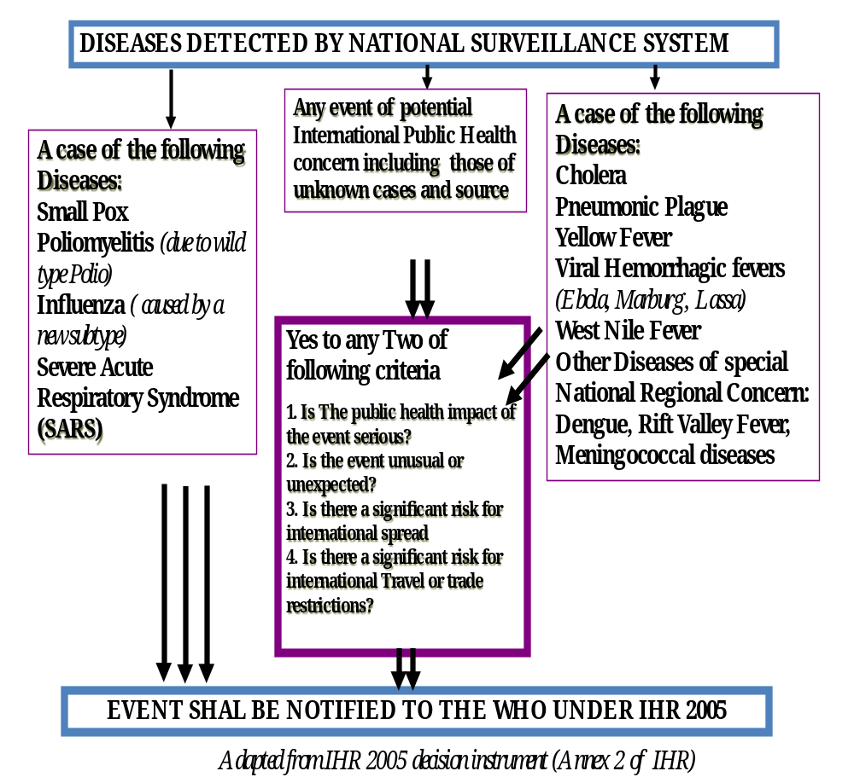

ANNEX 3
INTERNATIONAL HEALTH REGULATIONS (2005)
DEFINITIONS,
For the purposes of the International Health Regulations (hereinafter “the IHR” or “Regulations”):
- “affected” means persons, baggage, cargo, containers, conveyances, goods, postal parcels or human remains that are infected or contaminated, or carry sources of infection or contamination, so as to constitute a public health risk;
- “affected area” means a geographical location specifically for which health measures have been recommended by WHO under these Regulations;
- “aircraft” means an aircraft making an international voyage;
- “airport” means any airport where international flights arrive or depart;
- “arrival” of a conveyance means:
  - in the case of a seagoing vessel, arrival or anchoring in the defined area of a port;
  - in the case of an aircraft, arrival at an airport;
  - in the case of an inland navigation vessel on an international voyage, arrival at a point of entry;
  - in the case of a train or road vehicle, arrival at a point of entry;
- “baggage” means the personal effects of a traveller;
- “cargo” means goods carried on a conveyance or in a container;
- “competent authority” means an authority responsible for the implementation and application of health measures under these Regulations;
- “container” means an article of transport equipment:
  - of a permanent character and accordingly strong enough to be suitable for repeated use;
  - specially designed to facilitate the carriage of goods by one or more modes of transport, without intermediate reloading;
  - fitted with devices permitting its ready handling, particularly its transfer from one mode of transport to another; and
  - specially designed as to be easy to fill and empty;
- “container loading area” means a place or facility set aside for containers used in international traffic;
- “contamination” means the presence of an infectious or toxic agent or matter on a human or animal body surface, in or on a product prepared for consumption or on other inanimate objects, including conveyances, that may constitute a public health risk;
- “conveyance” means an aircraft, ship, train, road vehicle or other means of transport on an international voyage;
- “conveyance operator” means a natural or legal person in charge of a conveyance or their agent;
- “crew” means persons on board a conveyance who are not passengers;
- “decontamination” means a procedure whereby health measures are taken to eliminate an infectious or toxic agent or matter on a human or animal body surface, in or on a product prepared for consumption or on other inanimate objects, including conveyances, that may constitute a public health risk;
- “departure” means, for persons, baggage, cargo, conveyances or goods, the act of leaving a territory;
- “deratting” means the procedure whereby health measures are taken to control or kill rodent vectors of human disease present in baggage, cargo, containers, conveyances, facilities, goods and postal parcels at the point of entry;
- “Director-General” means the Director-General of the World Health Organization;
- “disease” means an illness or medical condition, irrespective of origin or source, that presents or could present significant harm to humans;
- “disinfection” means the procedure whereby health measures are taken to control or kill infectious agents on a human or animal body surface or in or on baggage, cargo, containers, conveyances, goods and postal parcels by direct exposure to chemical or physical agents;
- “disinsection” means the procedure whereby health measures are taken to control or kill the insect vectors of human diseases present in baggage, cargo, containers, conveyances, goods and postal parcels;
- “event” means a manifestation of disease or an occurrence that creates a potential for disease;
- “free pratique” means permission for a ship to enter a port, embark or disembark, discharge or load cargo or stores; permission for an aircraft, after landing, to embark or disembark, discharge or load cargo or stores; and permission for a ground transport vehicle, upon arrival, to embark or disembark, discharge or load cargo or stores;
- “goods” mean tangible products, including animals and plants, transported on an international voyage, including for utilization on board a conveyance;
- “ground crossing” means a point of land entry in a State Party, including one utilized by road vehicles and trains;
- “ground transport vehicle” means a motorized conveyance for overland transport on an international voyage, including trains, coaches, lorries and automobiles;
- “health measure” means procedures applied to prevent the spread of disease or contamination; a health measure does not include law enforcement or security measures;
- “ill person” means an individual suffering from or affected with a physical ailment that may pose a public health risk;
- “infection” means the entry and development or multiplication of an infectious agent in the body of humans and animals that may constitute a public health risk;
- “inspection” means the examination, by the competent authority or under its supervision, of areas, baggage, containers, conveyances, facilities, goods or postal parcels, including relevant data and documentation, to determine if a public health risk exists;
- “international traffic” means the movement of persons, baggage, cargo, containers, conveyances, goods or postal parcels across an international border, including international trade; “international voyage” means:
  - in the case of a conveyance, a voyage between points of entry in the territories of more than one State, or a voyage between points of entry in the territory or territories of the same State if the conveyance has contacts with the territory of any other State on its voyage but only as regards those contacts;
  - in the case of a traveller, a voyage involving entry into the territory of a State other than the territory of the State in which that traveler commences the voyage;
- “intrusive” means possibly provoking discomfort through close or intimate contact or questioning;
- “invasive” means the puncture or incision of the skin or insertion of an instrument or foreign material into the body or the examination of a body cavity. For the purposes of these Regulations, medical examination of the ear, nose and mouth, temperature assessment using an ear, oral or cutaneous thermometer, or thermal imaging; medical inspection; auscultation; external palpation; retinoscopy; external collection of urine, faeces or saliva samples; external measurement of blood pressure; and electrocardiography shall be considered to be non-invasive;
- “isolation” means separation of ill or contaminated persons or affected baggage, containers, conveyances, goods or postal parcels from others in such a manner as to prevent the spread of infection or contamination;
- “medical examination” means the preliminary assessment of a person by an authorized health worker or by a person under the direct supervision of the competent authority, to determine the person’s health status and potential public health risk to others, and may include the scrutiny of health documents, and a physical examination when justified by the circumstances of the individual case;
- “National IHR Focal Point” means the national centre, designated by each State Party, which shall be accessible at all times for communications with WHO IHR Contact Points under these Regulations;
- “Organization” or “WHO” means the World Health Organization;
- “permanent residence” has the meaning as determined in the national law of the State Party concerned;
- “personal data” means any information relating to an identified or identifiable natural person;
- “point of entry” means a passage for international entry or exit of travellers, baggage, cargo, containers, conveyances, goods and postal parcels as well as agencies and areas providing services to them on entry or exit;
- “port” means a seaport or a port on an inland body of water where ships on an international voyage arrive or depart;
- “postal parcel” means an addressed article or package carried internationally by postal or courier services;
- “public health emergency of international concern” means an extraordinary event which is determined, as provided in these Regulations:
  - to constitute a public health risk to other States through the international spread of disease and
  - to potentially require a coordinated international response;
- “public health observation” means the monitoring of the health status of a traveller over time for the purpose of determining the risk of disease transmission;
- “public health risk” means a likelihood of an event that may affect adversely the health of human populations, with an emphasis on one which may spread internationally or may present a serious and direct danger;
- “quarantine” means the restriction of activities and/or separation from others of suspect persons who are not ill or of suspect baggage, containers, conveyances or goods in such a manner as to prevent the possible spread of infection or contamination;
- “recommendation” and “recommended” refer to temporary or standing recommendations issued under these Regulations;
- “reservoir” means an animal, plant or substance in which an infectious agent normally lives and whose presence may constitute a public health risk;
- “road vehicle” means a ground transport vehicle other than a train;
- “scientific evidence” means information furnishing a level of proof based on the established and accepted methods of science;
- “scientific principles” means the accepted fundamental laws and facts of nature known through the methods of science;
- “ship” means a seagoing or inland navigation vessel on an international voyage;
- “standing recommendation” means non-binding advice issued by WHO for specific ongoing public health risks pursuant to Article 16 regarding appropriate health measures for routine or periodic application needed to prevent or reduce the international spread of disease and minimize interference with international traffic;
- “surveillance” means the systematic ongoing collection, collation and analysis of data for public health purposes and the timely dissemination of public health information for assessment and public health response as necessary;
- “suspect” means those persons, baggage, cargo, containers, conveyances, goods or postal parcels considered by a State Party as having been exposed, or possibly exposed, to a public health risk and that could be a possible source of spread of disease;
- “temporary recommendation” means non-binding advice issued by WHO pursuant to Article 15 for application on a time-limited, risk-specific basis, in response to a public health emergency of international concern, so as to prevent or reduce the international spread of disease and minimize interference with international traffic;
- “temporary residence” has the meaning as determined in the national law of the State Party concerned;
- “traveller” means a natural person undertaking an international voyage;
- “vector” means an insect or other animal which normally transports an infectious agent that constitutes a public health risk;
- “verification” means the provision of information by a State Party to WHO confirming the status of an event within the territory or territories of that State Party;
- “WHO IHR Contact Point” means the unit within WHO which shall be accessible at all times for communications with the National IHR Focal Point.

ANNEX 4
Replica of a Case Investigation Form (CIF) for PHEIC

1. ID NO: Date:

2. Name of facility sending the sample:……………………………………………………

3. Name of the case: …………………………………………………………………………..

4. Father’s/ Husband Name:…………………………………………………………………..

5. Address:………………………………………………………………………………………
…………………………………Contact Mobile Number:……………………………

6. Age: …….. year;………….month

7. Sex: |___|1=Male; 2= Female

8. Religion: |___| 1= Muslim; 2=Hindu; 3= Christians; 4= Buddha; 5= Others

9. Occupation: |___| 1=Farmer; 2= Student; 3= Children; 4= Business man; 5= Service;
6= Housewife; 7= Others (mention)……………………..

10. H/O travel to affected country/ area|___|1= yes; 2= No

11. Name of affected country(ies) visited………………………………………………….

12. Contact with a case of PHEIC |___| 1= yes; 2= No

13. Acute febrile respiratory disease with fever (>38⁰C/(>100.4⁰F) with spectrum of Influenza
Like Illness (ILI) to Pneumonia|___| 1= yes; 2= No (Example for an PHEIC: A(H1N1) suspect)

14. Manifestation (Example for an PHEIC: A(H1N1) suspect)
a. Fever (>100.4⁰F) |___| 1= yes; 2= No
b. Sore throat|___| 1= yes; 2= No
c. Cough|___| 1= yes; 2= No
d. Runny nose|___| 1= yes; 2= No
e. Pneumonia|___| 1= yes; 2= No

15. Any other family member affected|___| 1= yes; 2= No

16. If yes number |___|___|

17. Sample collected (As needed for the PHEIC) |___| 1= yes; 2= No

18. Name of the data collector with signature and Mobile Number:

ANNEX 5: Sample Health Card of a PHEIC-Influenza A(H1N1)

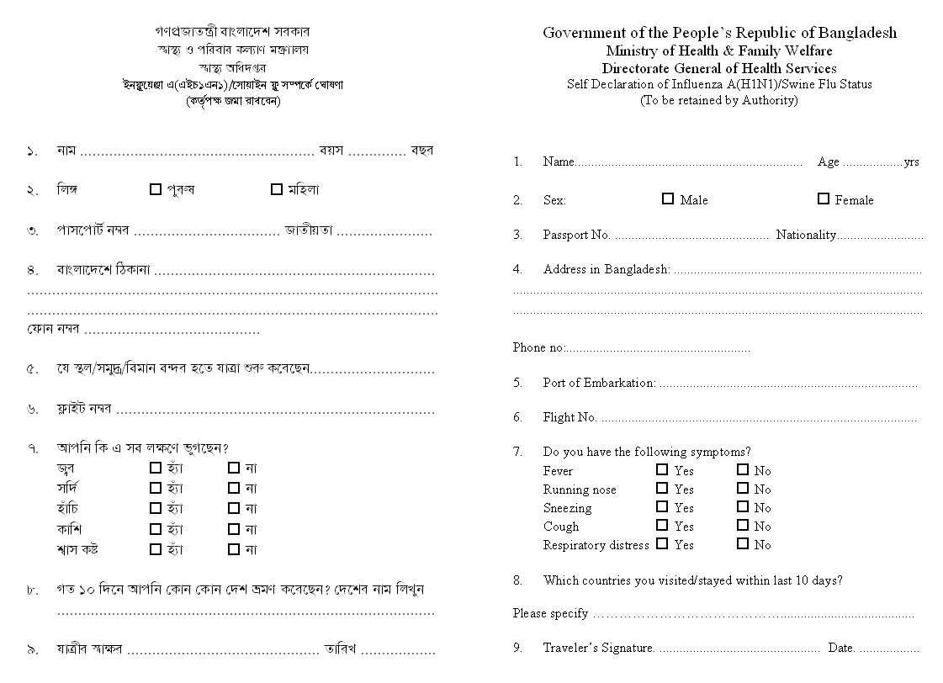
ANNEX 6

Example of Flow Chart for an PHEIC

Flow Chart for Management of Influenza A(H1N1) [ Swine]
Suspect of Influenza A (H1N1) Swine Flu
A suspect case is defined as an individual with an acute febrile respiratory illness (fever > 100.4°F/ 38°C ) with the spectrum of disease from influenza-like illness (ILI) to pneumonia and is considered to be epidemiologically linked to a probable or confirmed case.

If result is Negative
If result is Positive
Contact National Influenza Centre (NIC) at IEDCR (hot line 01937000011, 01937110011)
Fill in the Case Investigation Form
Collect throat swab and nasal swab in Viral Transport Media
Send the sample to NIC
Instruct the suspect for home confinement till the result of test is available

Treatment with Oseltamivir for 5 days
Continuation of home confinement up to 10 days from start of manifestation
If condition deteriorates refer the patient to hospital with isolation facilities (NIDCH-Dhaka, Sadar hospital, Medical College Hospitals)
Inform the negative result
Withdraw confinement
ANNEX 7: Example of Flyers used at Health Support Desk during outbreak of Swine flu
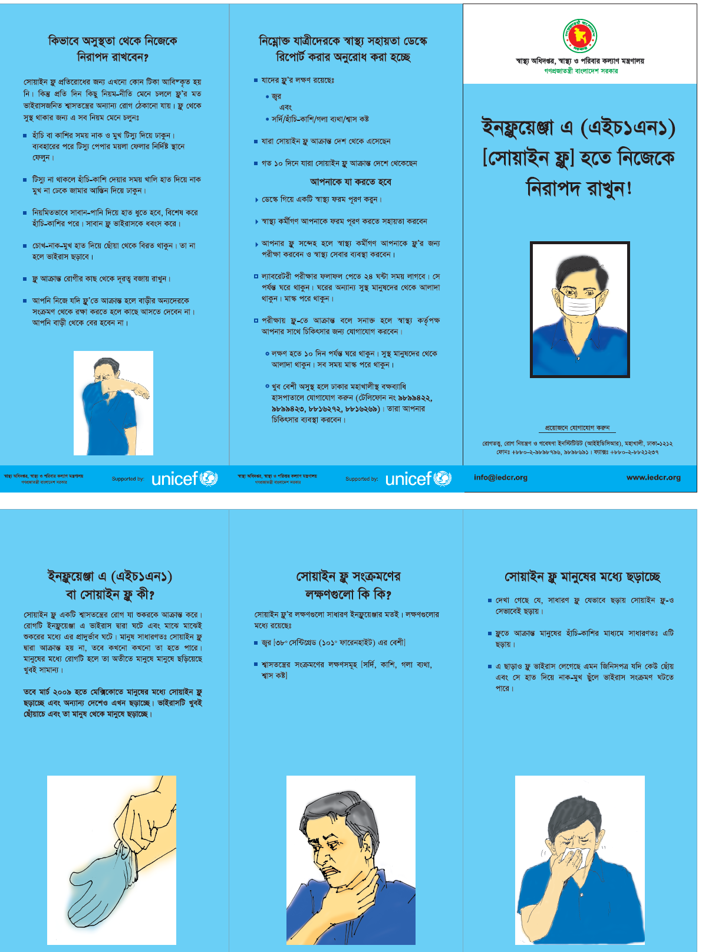
ANNEX 8

TECHNICAL REQUIREMENTS PERTAINING TO CONVEYANCES AND
CONVEYANCE OPERATORS

Section A Conveyance operators
1. Conveyance operators shall facilitate:
(a) inspections of the cargo, containers and conveyance;
(b) medical examinations of persons on board;
(c) application of other health measures under these Regulations; and
(d) provision of relevant public health information requested by the State Party.

2. Conveyance operators shall provide to the competent authority a valid Ship Sanitation Control
Exemption Certificate or a Ship Sanitation Control Certificate or a Maritime Declaration of Health, or the Health Part of an Aircraft General Declaration, as required under these Regulations.

Section B Conveyances
1. Control measures applied to baggage, cargo, containers, conveyances and goods under these
Regulations shall be carried out so as to avoid as far as possible injury or discomfort to persons or damage to the baggage, cargo, containers, conveyances and goods. Whenever possible and
appropriate, control measures shall be applied when the conveyance and holds are empty.

2. States Parties shall indicate in writing the measures applied to cargo, containers or conveyances, the parts treated, the methods employed, and the reasons for their application. This information shall be provided in writing to the person in charge of an aircraft and, in case of a ship, on the Ship Sanitation Control Certificate. For other cargo, containers or conveyances, States Parties shall issue such information in writing to consignors, consignees, carriers, the person in charge of the conveyance or their respective agents.

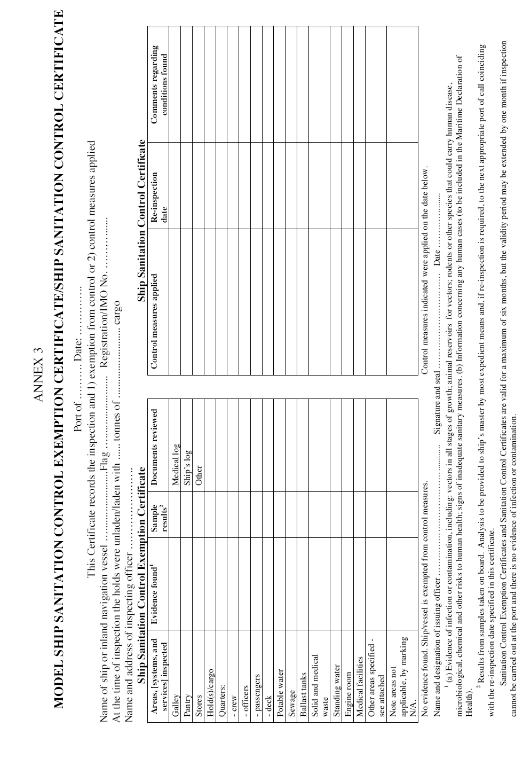
Annex 9

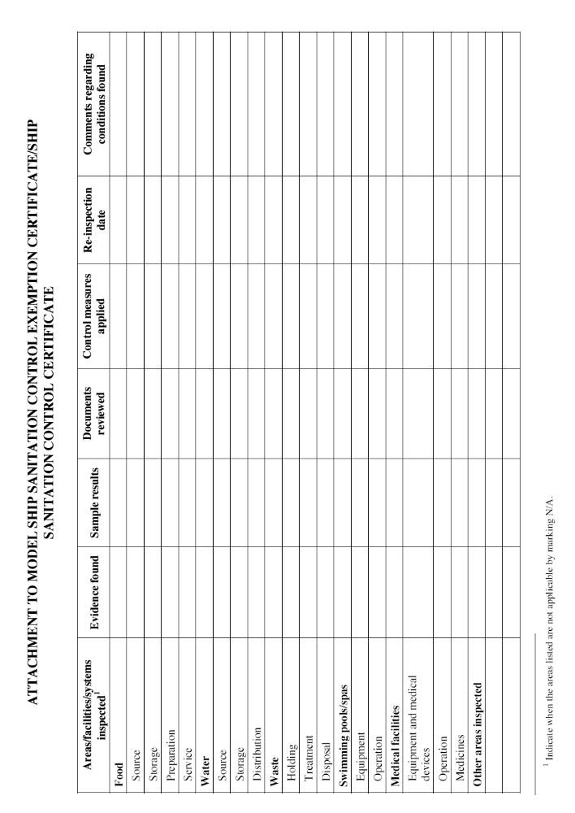
ANNEX 10 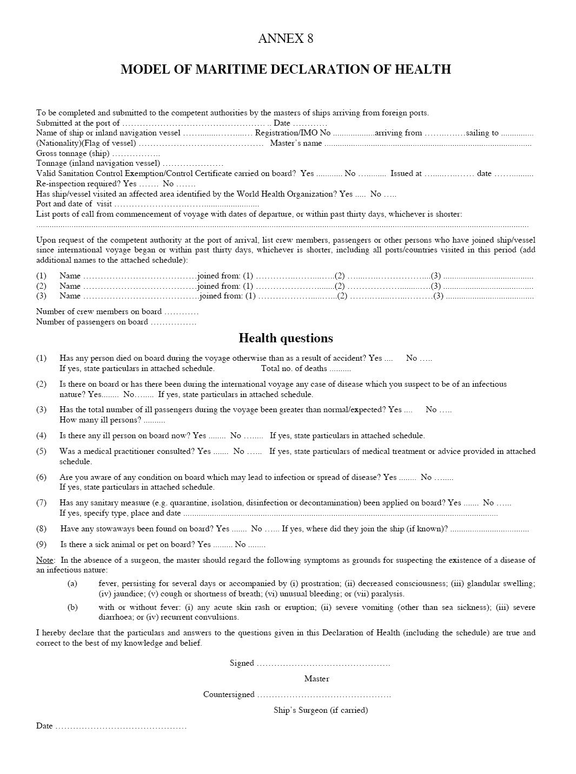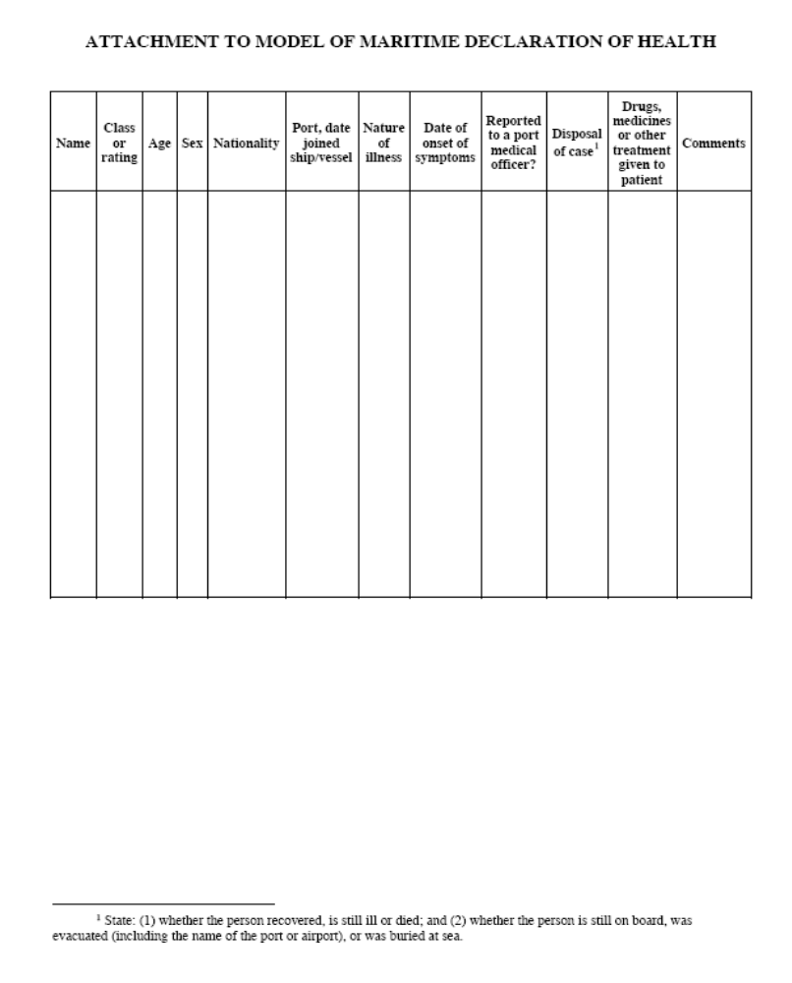
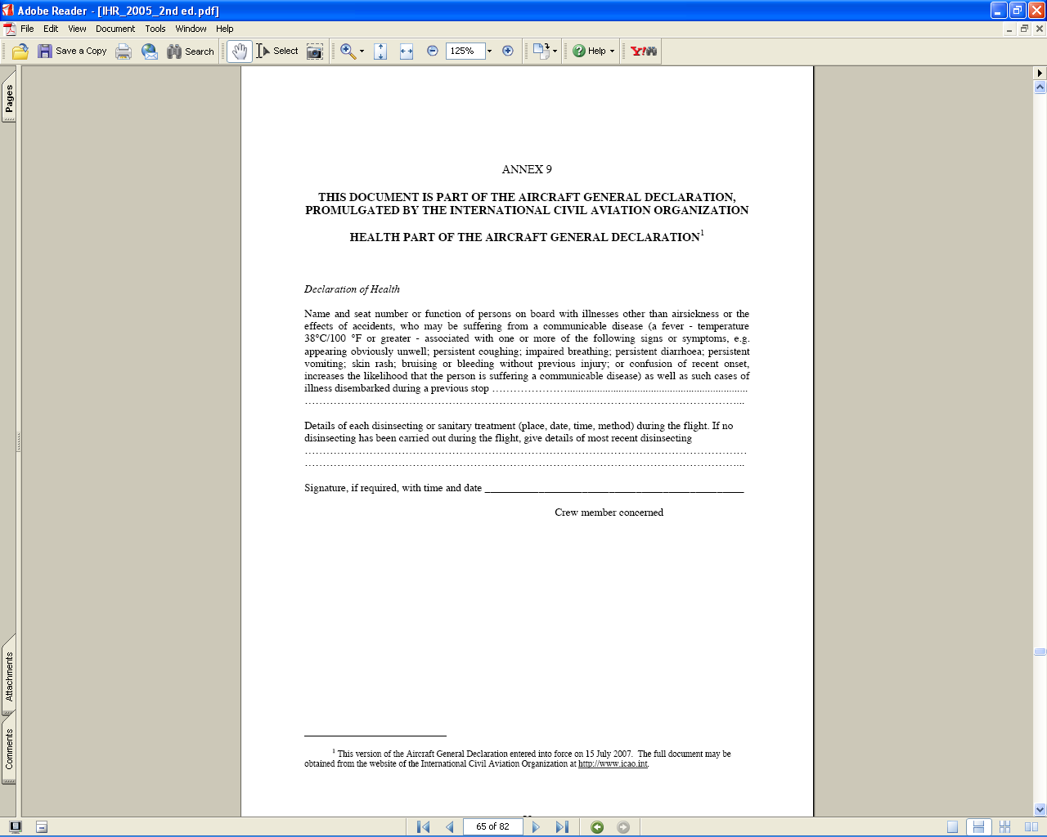
ANNEX 11

